Oxbridge Lane Primary School
Starting School Expectations
 | Tip | How can I help?
1 | I am independent  I can blow my nose, wash my hands and go to the toilet, all on my own.  I can eat my packed lunch by myself, even undoing the wrappers.  I can put on my own coat and do it up. | Washing hands - https://www.youtube.com/watch?v=S9VjeIWLnEg  Toileting –  https://www.eric.org.uk/thinking-about-wee-and-poo-now-youre-on-your-way-to-school
2 | I can run, jump, climb and move around confidently | Fun activities –  https://activeforlife.com/49-fun-physical-activities-to-do-with-kids-aged-2-to-4/
3 | I can confidently communicate and make my needs known to other people | This website has ideas for everyday activities you can do with babies and young children to help them develop their communication skills:  https://hungrylittleminds.campaign.gov.uk/#3
4 | I can join in with activities and sing rhymes and songs | Sing at every opportunity! Here are some songs that you and your child might like: https://www.bbc.co.uk/cbeebies/curations/nursery-rhymes
5 | I can listen and take turns in a conversation | Take a look at this website, it is full of exciting everyday activities you can do with babies and young children to help them develop their communication and language skills:  https://hungrylittleminds.campaign.gov.uk/#3
6 | I can share books and talk about the pictures and storylines | See the section below on preparation for starting school – recommended reads.
7 | I can draw and make marks with pencils, crayons and pens and use scissors safely | Just have fun drawing and making marks with your child! If you have an outdoor space use big chalks and mark on the ground and then enjoy washing the marks away.  Practise using scissors to snip and cut all sorts of shapes and show your child how to hold the scissors correctly. Try different materials - you don’t have to just use paper.  By making marks and using scissors, children will be developing their hand strength and this will help them when they start writing. Using other tools and equipment will help too - can your child help with gardening or cooking and use the equipment needed, can they practice using knives and forks?
8 | I can concentrate on something that interests me and carry out an activity | Encourage your child to stick at an activity for a few minutes and talk about what they have achieved. You could plan your day with your child so they can make some choices of their own and have lots of opportunities to talk about what they are doing and learning.  Can you set them a challenge? Use a timer on your phone to see how long they can keep going. Let them set you a challenge too so they can time you!
9 | I can take turns and share with other people | Try playing some board games or turn taking games over the summer holidays. Play catch or roll a ball between you or take turns on a slide in the park. Encourage children to take turns and share their toys with their friends or siblings - give them lots of praise when they do.
10 | I am excited, curious and enthusiastic about learning in my new school! | Be positive about the start of school. You could read some stories together. Oxford Owl is a website with some good, free books.  Have a look at our website and transition booklets look at the photos of the staff who will be teaching your child and what the classrooms, hall, play grounds look like.

Preparation for starting School
There are some wonderful books available to help prepare your child for school. These can be used in the build up to starting in Reception. Many of these can be found in Stockton library.
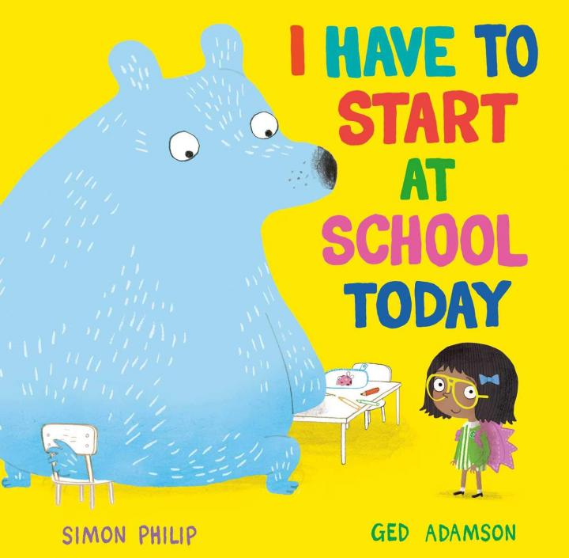
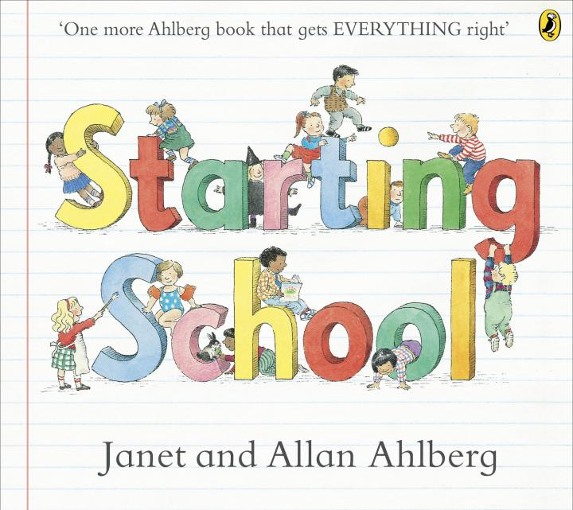
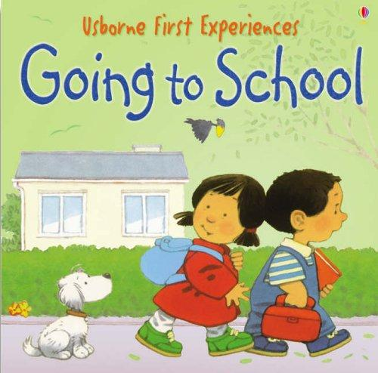
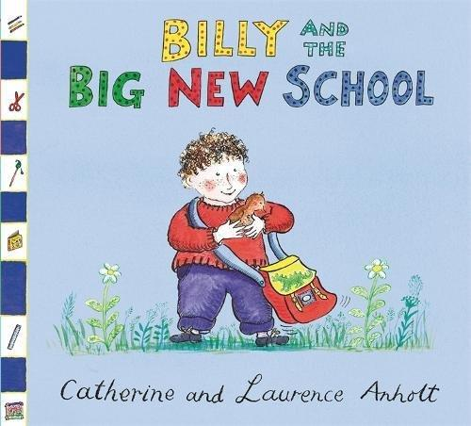
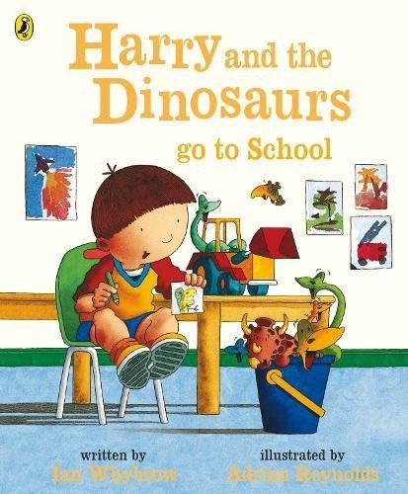
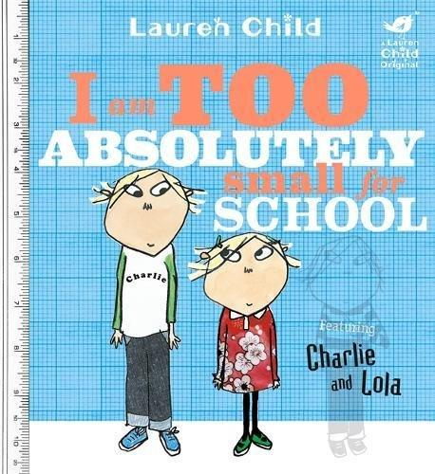
There are also lots of recommended reads to share with your child to help develop a love of reading.
- 'Oi Frog' by Kes Gray and Jim Field
- 'We're Going on a Bear Hunt' by Michael Rosen and Helen Oxenbury
- 'Shark in the Park' by Nick Sharratt
- 'Dinosaurs Love Underpants' by Claire Freedman and Ben Cort
- 'Mixed up Fairy Tales' by Hilary Robinson and Nick Sharratt
- 'This Old Man' by Pam Adams
- 'Owl Babies' by Martin Wadell

